Lab Report Framework

**Name**

**Date**

**Grade**

**TITLE OF THE LAB**

**C:\Users\jmedenica\AppData\Local\Microsoft\Windows\Temporary Internet Files\Content.IE5\V4OM9PVQ\MCj04419020000[1].wmfGUIDING QUESTION/S:** (States the guiding question/s or problem to be solved):

What do you want to research or investigate?

**C:\Users\jmedenica\AppData\Local\Microsoft\Windows\Temporary Internet Files\Content.IE5\DN896E64\MCj04419300000[1].wmfHYPOTHESIS:** If you have an idea about why something happens, make an educated

guess, or hypothesis. What do you predict will occur?

**EXPLORATION** **(Plan & do a test):**

**(Variables) Controlled:** Things you keep the same.

**Manipulated:** The change YOU make to the experiment.

**Responding:** The response to the change (What you are looking to

happen).

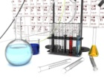 (**Materials**) List the instruments and materials you will use

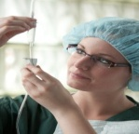(**Procedure**) Lists the steps required to replicate the experiment

**RECORD & ANALYZE** :

Observe carefully and write down, or record, everything that

happens. When you finish collecting data, you may need to do some calculations with it and/or organize it with a graph.)

1. **Data Tables:**

-Give proper title of table and column headings

-Use an appropriate orientation

-Make correct computations

-Use correct units of measurement in the column headings ONLY

-Observe significant figures and rounding-off rules

1. C:\Users\jmedenica\AppData\Local\Microsoft\Windows\Temporary Internet Files\Content.IE5\V4OM9PVQ\MCj04418840000[1].wmf**Graphs:**

-Give a proper title for the graph

-Give a proper title for each axis

-Give a legend for each axis

-Use an appropriate orientation

1. 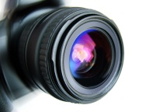**Images/Video:** You may wish to make a video or take photos of your

process and data collection, as well as the results of your experimental procedure. You can include them in this section of your lab report. However, be sure to include a title of each image or video, as well as a caption underneath it for clarification.

1. 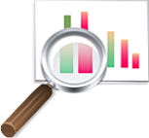**Data Analysis:** Do you see any patterns/relationships in your data table

and/or graph? Do you believe that your data shows accuracy and precision? **You are not giving your opinions here**, just simply explaining your data.

**C:\Users\jmedenica\AppData\Local\Microsoft\Windows\Temporary Internet Files\Content.IE5\DN896E64\MCj00787720000[1].wmfCONCLUSION:** State the guiding question. What can you conclude about

the evidence you collected? How does it help you to answer your guiding question? Was your hypothesis (prediction) correct? If yes, explain. If no, explain what you understand now about this investigation and how it taught you something new.

C:\Users\jmedenica\AppData\Local\Microsoft\Windows\Temporary Internet Files\Content.IE5\TGW3IW96\MCj04344110000[1].wmf**FURTHER INQUIRY:**

*This is perhaps one of the most important parts of the lab report.*

Step 1: Examine the validity of your data and infer what you think the major causes of error may have been. Describe ways to improve the procedure to eliminate any errors or flaws in the experiment if you were to do it again. For example, what modifications (changes) would you need to make or would make next time?

Step 2: Do you have any further questions or ideas about the experiment? You should write them in this section. Whatever happens in a test, think about all the reasons for your results. Sometimes this thinking leads to a new hypothesis. Write down these new hypotheses (predictions) or inquiries (questions) you may have that you could test next time.

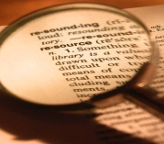**REFERENCES:** Did you use any websites or books, magazines to help you gain

knowledge about your investigation? Be sure to give credit to those sources you used.

**C:\Users\jmedenica\AppData\Local\Microsoft\Windows\Temporary Internet Files\Content.IE5\PGKQ2WZG\MC900391702[1].wmfSHARE:** Collaboration is one of the most important things in the development of

scientific ideas and solutions to global issues. After finalizing your lab report rough draft, be ready to share in some way your investigation data and conclusions. Be sure you are aware of and use the evidence that you collected when presenting. You may wish to publish to your blog, create a poster for class, or present your data via the in-class projector.