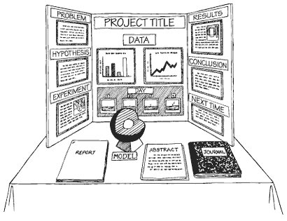
Science Fair Project
Part I – BACKGROUND RESEARCH
The Background Research section of your Scientific Inquiry Project is a written report, NOT an experiment. You can use text books, library books, periodicals, personal interviews with scientists who are already experts in those fields, internet sites, etc. to gather information about the topic. You will write a report with all the information you already know about the topic. We will spend some class time doing research on the internet. You will need to finish the report on your own, at home, as homework. You can share your research with your partner, but each one of you needs to write your own paper! This section will give you the information you need to know before writing the Hypothesis. That’s the next step in your Scientific Inquiry Project. When you finish the Background Research, you’re done with the hardest and longest part.

Report Requirements
- The report should be directly related to the topic of your scientific inquiry project. It should help you form your hypotheses.
- You must take notes so that you aren’t tempted to plagiarize.
- Background research will be 2 pages typed. Plus bibliography and labeled diagrams for groups, it will be two pages INCLUDING bibliography and labeled diagram. (1.5 page of writing, ½ page of diagram & bibliography)
- Please use 12 font & double space.
- NO italics or fancy fonts, please.
- NO reports w/all capital letters. Only use capital letters when needed.
- There will be at least one labeled diagram. The diagram should relate directly to your inquiry project.
- You will be compiling your Bibliography at the same time you take your notes for the report. If you have forgotten how to write a bibliography, the following website will tell you everything you ever wanted to know about writing a Bibliography. You need AT LEAST 3 references.
http://www.bibme.org/citation-guide/MLA/website
http://www.easybib.com/

