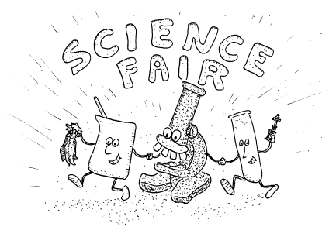

Science Fair Ideas - How to Find a Good Idea

Ways to find a science fair project idea…
- Look for Science Categories
Look at lists of science categories and pick one that you are interested in, then narrow that down to a project. (example, say you pick psychology, then narrow it to the differences between boys and girls, then to a topic like "Do boys remember boy-type pictures (footballs) better than girl-type pictures (flowers)?" (Two lists of categories attached)

- Use Your Experience
Use your experiences Remember a time you noticed something and thought "I wonder how that works?" or "I wonder what would happen if..." then turn that into a project. Check the science section of the library. Browse and look at book titles, then look inside the ones that look interesting to you. Also thumb through encyclopedias and magazines. Good magazines for ideas are: National Geographic, Discover, Omni, Popular Science, Popular Mechanics, Mother Earth News, High Technology, Prevention, and Garbage. Perhaps go to the downtown Library.

- Think about Current Events
Think about current events. Look at the newspaper. People are hungry in Africa because of droughts - a project on growing plantswithout much rain, which types grow ok with little water? Or the ozone hole over Antartica - how can we reduce ozone? -a project on nonaerosol ways to spray things. Or oil spills. how can we clean them up? -a project on how to clean oil out of water

- Test Claims on TV commercials
Watch commercials on TV. Test their claims. Does that anti-perspirant really stop wetness better than other ones? What are the real differences between Barbie and imitation Barbie dolls? Can kids tell the difference between coke and pepsi if they don't know which they are drinking?

More Ideas:
Take these ideas and add something of your own, for example, change Are dogs colorblind? to Are cats colorblind? Or look at another of the 5 senses of dogs and test their sense of taste...
- What material is the best insulator?
- Are dogs colorblind?
- Do soap bubbles last longer on warm or cold days?
- What effect does oil have on water plants?
- What would happen to the weather if the Earth was a cube?
- Do goldfish chemicals they sell you really help the fish adapt to the new aquarium?
- How can a tomato plant be grafted to a potato plant?
- How is sound obtained from a compact disk?
- How is 2-yr old talk different from ours?
- What soils are best to build a house on?
- How do plants react to different kinds of music, different light, colors, and different neighbor plants?
- What is the best way to dispose of paper
- Do plants move?

Try putting different words in these blanks...
What is the effect of ____________ on _______________?
detergent | germination of seeds
temperature | the volume of air
How/to what extent does the _____________________ affect ___________________?
humidity | growth of fungi
color of a material | its absorption of heat

Which/what __________________ (verb) __________________?
foods | do | gerbils prefer
detergent | makes | the most bubbles

How do I select a high-quality science fair topic?

Think about…

Is my topic realistic?
Is it something I can do?
Is my topic interesting to me?
Can I investigate my topic by experimenting and collecting data?
Can I afford what I will need to investigate my topic?
Do I have enough time to research, complete the experiment, and create a science fair project?

Scoring extra points:
The science fair projects which attract the most attention share certain characteristics:
Is this project original, or has it been done before?
Is the answer to my question already known?
Will my investigation add to what is known about the topic?
Are there outside resources available to me? Have I narrowed results from all possible angles?
Authors: Dr. Marszalek , Mrs. Mazanek , and Mrs. Mohr
School: Twin Groves Middle School, Buffalo Grove, Illinois 60089
Created: 15 June 1997; Modified: 21 September 2004
Web Access on 29, September 2013, http://www.district96.k12.il.us/TG/ScienceInternet/ProjectIdeas.html

